Dear Parents,

Welcome to a new school year! I know that each year your child is presented with new expectations and routines. My goal is to introduce these classroom routines and structures in a way that removes all of the guesswork from the children and allows them to concentrate fully on learning. In reading, the classroom structures we are using this year are called, “Daily Five”. The purpose of this letter is to explain to you what it is and what you might expect to see at home.

The Daily Five is a literacy structure that teaches independence and gives children the skills needed to create a lifetime love of reading and writing. It consists of five tasks that are introduced individually. When introduced to each task, the children discuss what it looks like, sounds like, and feels like to engage in the task independently. Then, the children work on building their stamina until they are successful at being independent while doing that task.

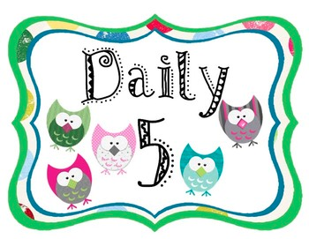
The five tasks include:
- Read to Self
- Read to Someone
- Listen to Reading
- Work on Writing
- Word Work

When all five tasks have been introduced and the children are fully engaged in reading and writing activities, I will be able to work with small groups and confer with them one on one. Research shows that this structure can be very effective.

We are also introducing the “Reading CAFÉ” menu goals and strategies. Think of it as a menu of focused reading strategies aimed to help each child improve at their level. CAFÉ is an acronym for Comprehension, Accuracy, Fluency, and Expanding Vocabulary.

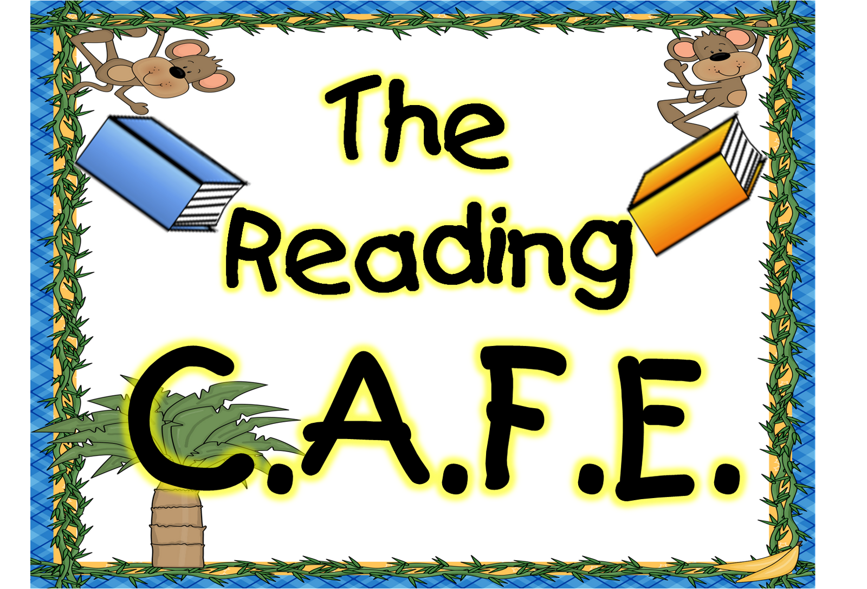

This program is new to our school this year, and I aim to do my best to help your child be successful in reading this year. Thank you for your continued support.

We are a TEAM!

Mrs. Bagaason

